
COMSATS University Islamabad
Programming Fundamentals
Fall 2025

NAME : SHEHRYAR KHURRAM

REGISTRATION NUMBER : FA25 – BDS - 045

CLASS : BDS - 1A

INSTRUCTOR : SIR KHURRAM IQBAL

LAB 6
TASK 1: The index of the maximum of a sequence: A sequence consists of integer numbers and ends with the number 0. Determine the index of the largest element of the sequence. If the highest element is not unique, print the index of the first of them.
2 3 2
INPUT (TASK 1): 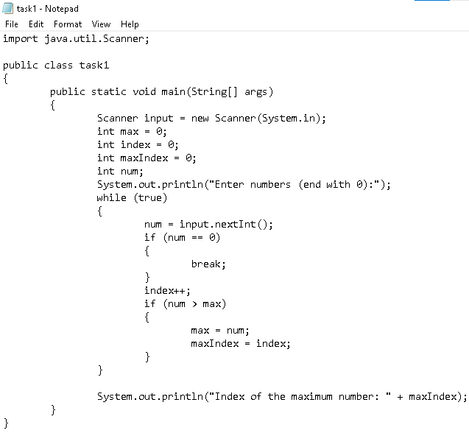1 0 Output:3

LAB 6
OUTPUT (TASK 1):
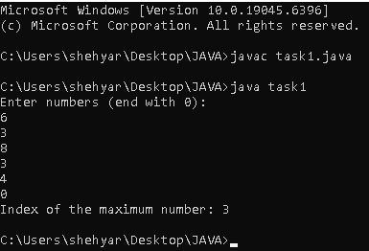

LAB 6
TASK 2: The number of even elements of the sequence: Determine the number of even elements in the sequence ending with the number 0.

INPUT (TASK 2):
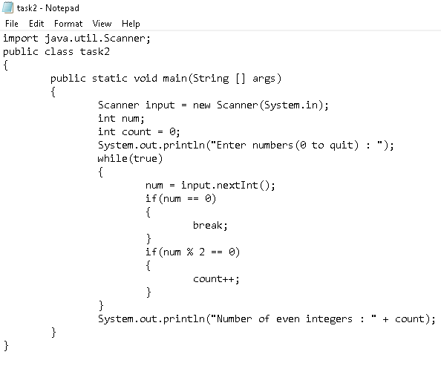

LAB 6
OUTPUT (TASK 2):
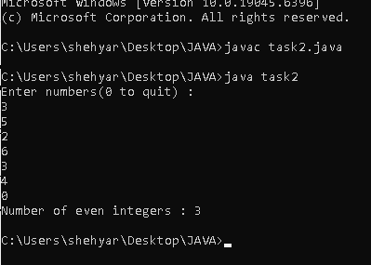

LAB 6
TASK 3: The number of elements that are greater than the previous one: A sequence consists of integer numbers and ends with the number 0. Determine how many elements of this sequence are greater than their neighbors above.

INPUT (TASK 3):
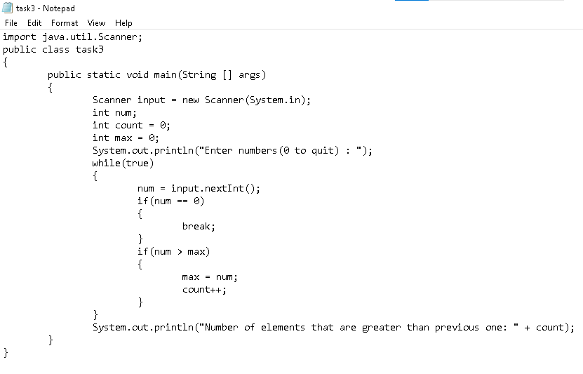

LAB 6
OUTPUT (TASK 3):
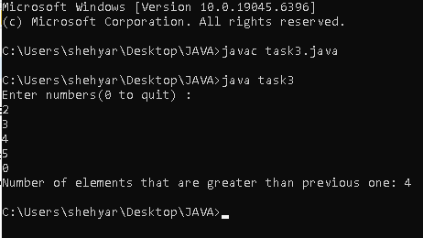

LAB 6
TASK 4: Write a program to print following. The program asks the user to enter the number which pattern he/she wants to print. The loop should ask the user whether he or she wishes to perform the operation again. If so, the loop should repeat; otherwise it should terminate.
INPUT (TASK 4):
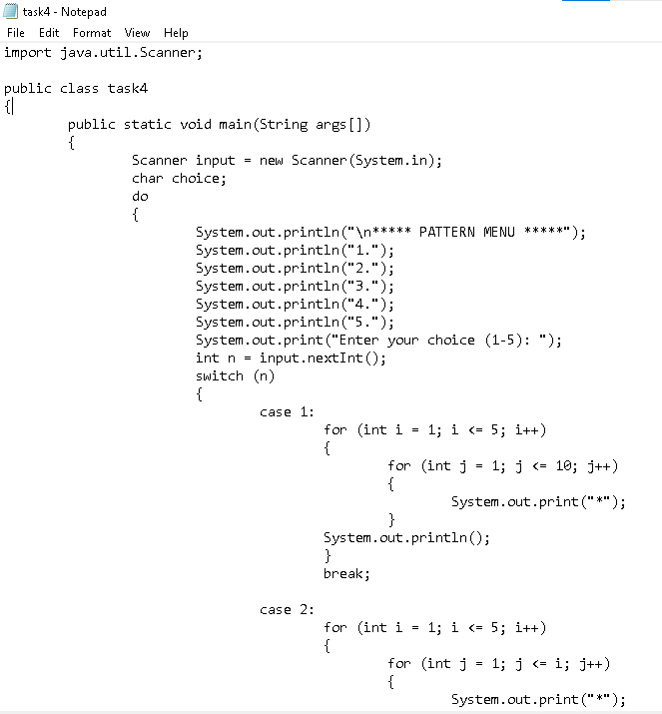
LAB 6
INPUT (TASK 4):
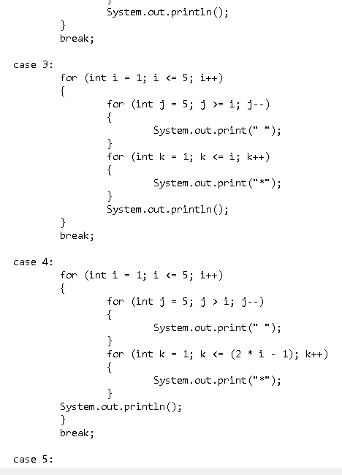

INPUT (TASK 4):
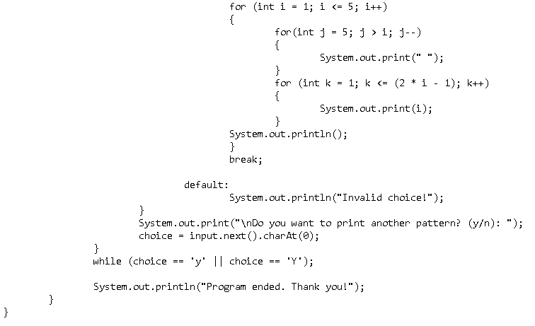
LAB 6
OUTPUT (TASK 4):
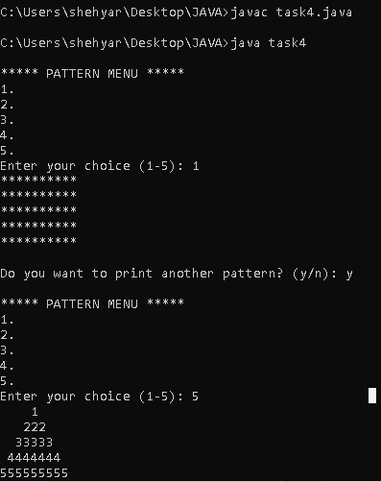

LAB 6
OUTPUT (TASK 4):
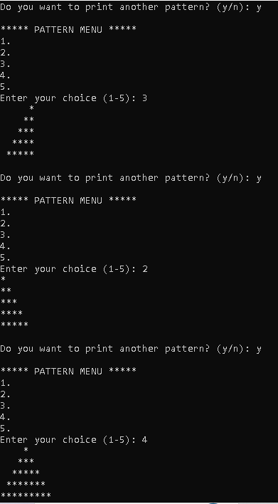

LAB 6
OUTPUT (TASK 4):
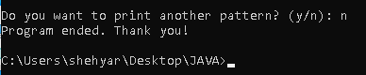
LAB 6
TASK 5: Write a program that prompts the user to enter the year and first day of the year and displays the calendar table for the year on the console. For example, if the user entered the year 2013, and 2 for Tuesday, January 1, 2013, your program should display the calendar for each month in the year.

INPUT (TASK 5):
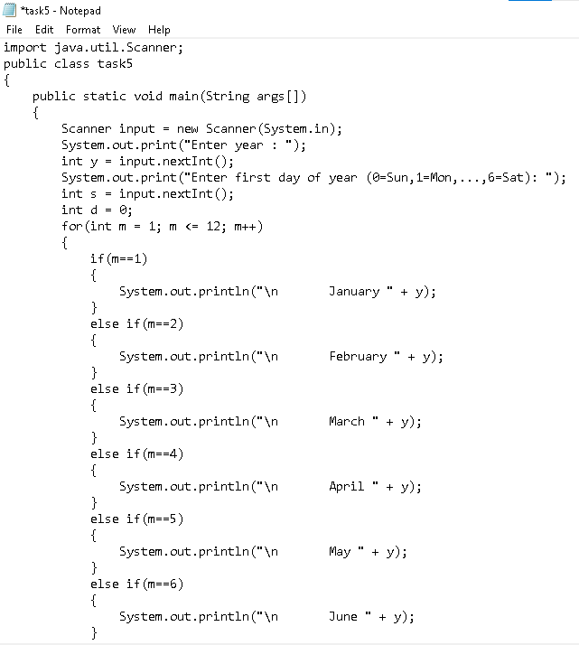

LAB 6
INPUT (TASK 5):
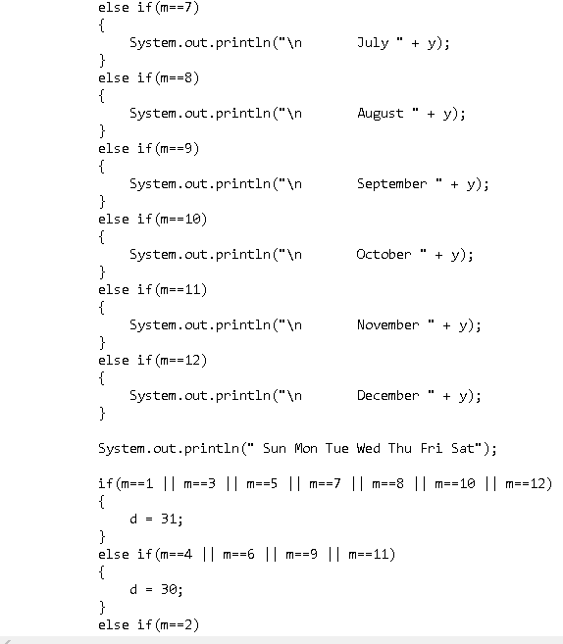

LAB 6
INPUT (TASK 5):
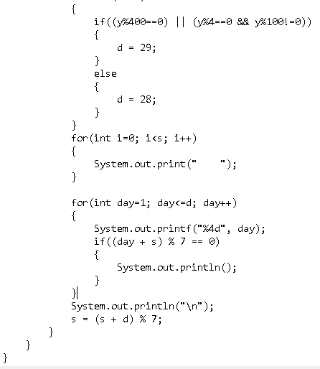

LAB 6
OUTPUT (TASK 5):
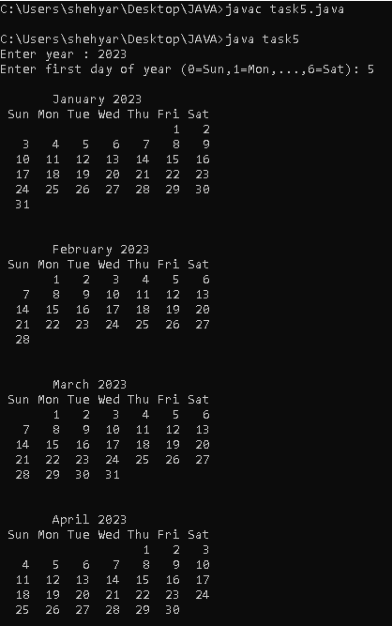

LAB 6
OUTPUT (TASK 5):
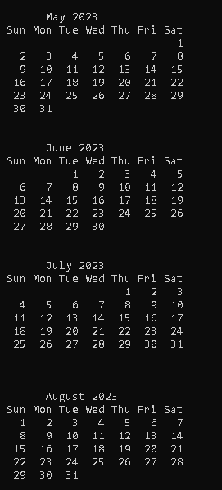

LAB 6
OUTPUT (TASK 5):
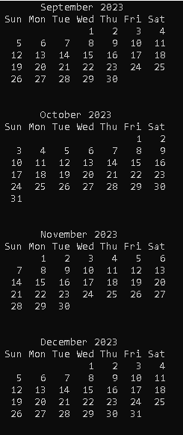

LAB 5
TASK 1A: Given two integers A and B (A ≤ B). Print all numbers from A to B inclusively.
INPUT (TASK 1A):
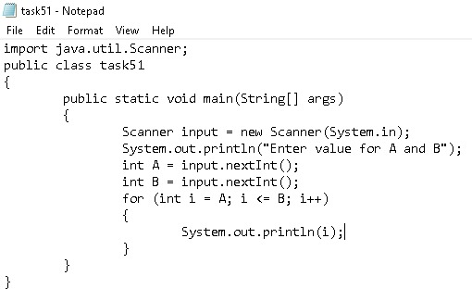

LAB 5

OUTPUT (TASK 1A):
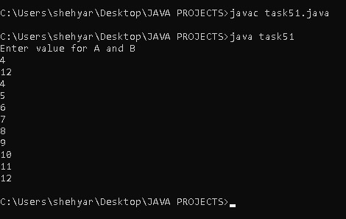

LAB 5
TASK 1B: Given two integers A and B. Print all numbers from A to B inclusively, in ascending order, if A < B, or in descending order, if A ≥ B
INPUT (TASK 1B):
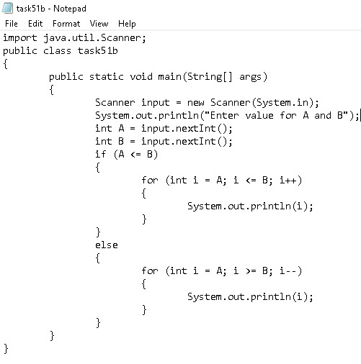

LAB 5
OUTPUT (TASK 1B):
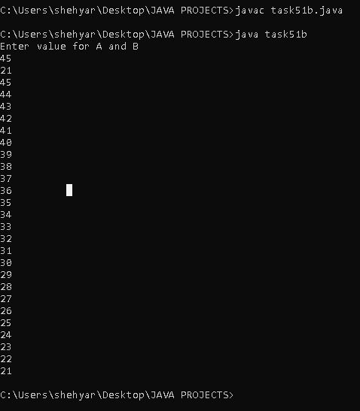
LAB 5
TASK 1C: Sum of N numbers: N numbers are given in the input. Read them and print their sum. The first line of input contains the integer N, which is the number of integers to follow. Each of the next N lines contains one integer. Print the sum of these N integers.
INPUT (TASK 1C):
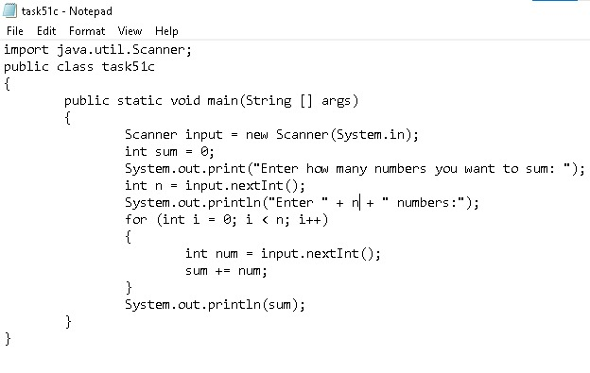

LAB 5
OUTPUT (TASK 1C):
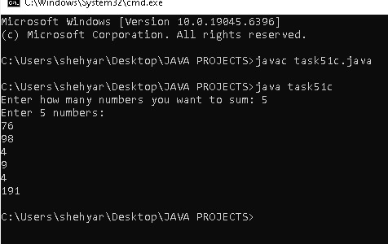

LAB 5
TASK 1D: d) Sum of Cubes: For the given integer N calculate the following sum:
13+23+…+N
INPUT (TASK 1D):
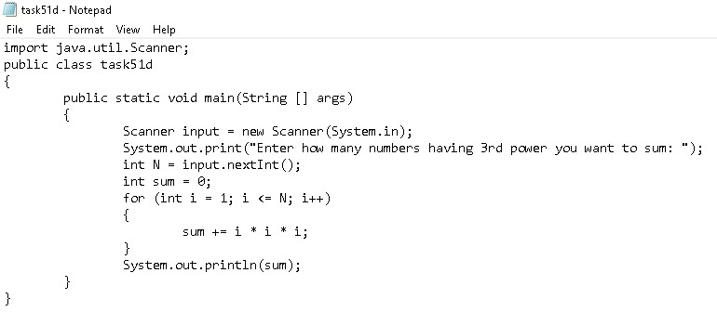

LAB 5
OUTPUT (TASK 1D):
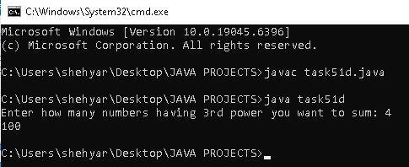

LAB 5
TASK 2: Factorial: In mathematics, the factorial of an integer n, denoted by n! is the following product:
n!=1×2×…×n
For the given integer n calculate the value n
INPUT (TASK 2):
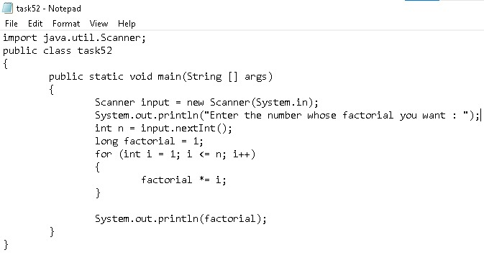

LAB 5
OUTPUT (TASK 2):
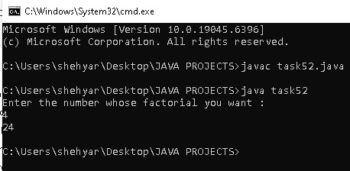

LAB 5
TASK 3: Number of zeros: Given N numbers: the first number in the input is N, after that N integers are given. Count the number of zeros among the given integers and print it. You need to count the number of numbers that are equal to zero, not the number of zero digits.
INPUT (TASK 3):
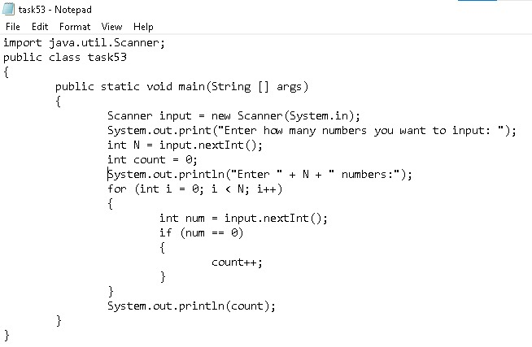

LAB 5
OUTPUT (TASK 3):
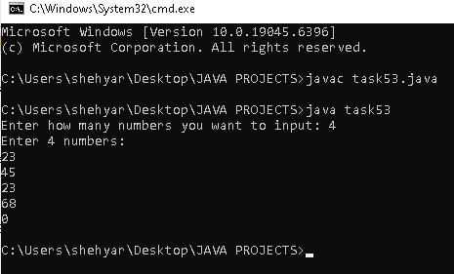
LAB 5
TASK 4: The length of Sequence: Given a sequence of non-negative integers, where each number is written in a separate line. Determine the length of the sequence, where the sequence ends when the integer is equal to 0. Print the length of the sequence (not counting the integer 0). The numbers following the number 0 should be omitted.
INPUT (TASK 4):
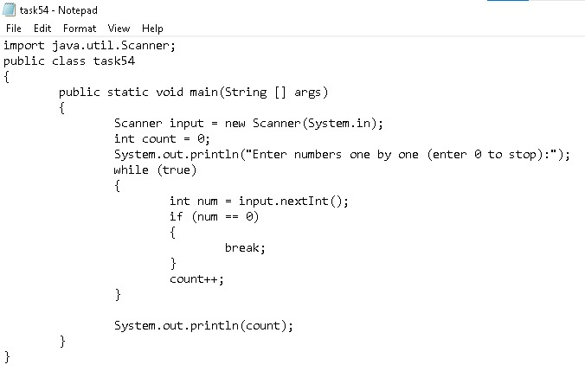

LAB 5
OUTPUT (TASK 4):
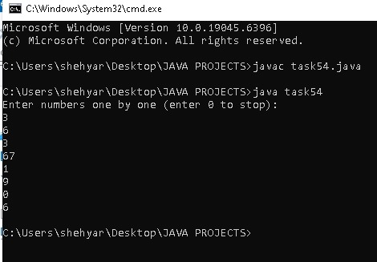

LAB 5
TASK 5: The maximum of the Sequence: A sequence consists of integer numbers and ends with the number 0.Determine the largest element of the sequence.
INPUT (TASK 5):
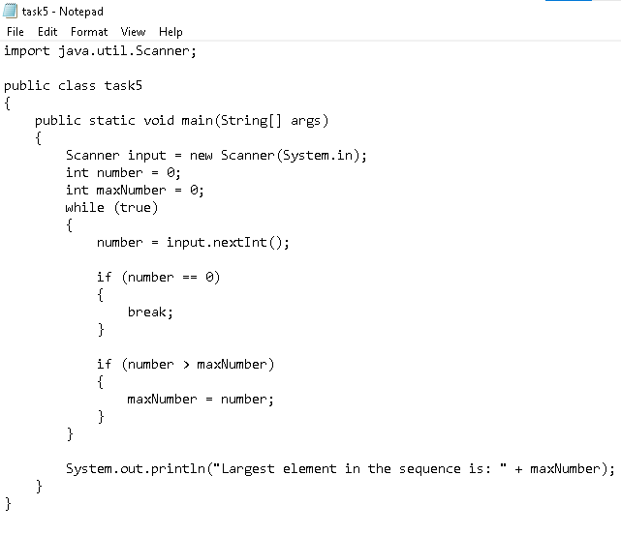

LAB 5
OUTPUT (TASK 5):
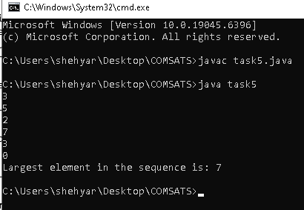

LAB 4
TASK 1: Suppose that x, y, and z are int variables and x = 10 , y = 15 , and z = 2 0. Determine whether the
following expressions evaluates to true or false .
!(x > 1 0)
x <= 5 || y < 15
(x != 5 ) && (y != z)
x >= z || (x + y >= z)
(x <= y – 2) && (y >= z) || (z – 2 != 20)
EVALUATION (TASK 1):
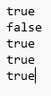

LAB 4
TASK 2: Suppose that x, y, z,and w are int variables and x = 3, y = 4, z = 7,and w =1. What is the output of the
following statements?
System.out.println("x == y: " + (x == y ));
System.out.println("x != z: " + (x != z ));
System.out.println("y == z – 3: " + (y == z – 3) );
System.out.println("!(z > w): " + ! (z > w));
System.out.println("x + y < z: " + (x + y < z));
EVALUATION (TASK 2):
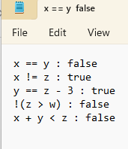

LAB 4
TASK 3: Consider the following code segment. Determine the value of b3
boolean b1=true;
boolean b2=false;
boolean b3=(b1==b2);
EVALUATION (TASK 3):

LAB 4
TASK 4A: a) Minimum of two numbers: Given two integers, print the smaller value
INPUT (TASK 4A):
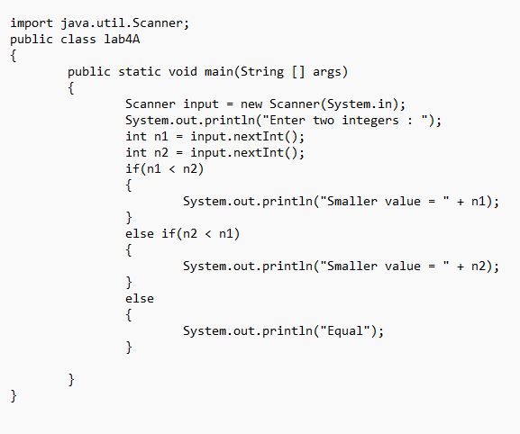
LAB 4
OUTPUT (TASK 4A):
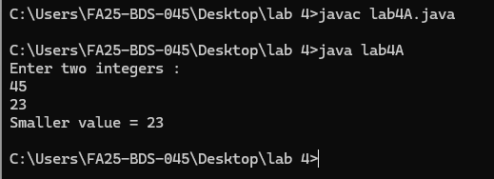

LAB 4
TASK 4C: Sign function: For the given integer X print 1 if it's positive, -1 if it's negative, or 0 if it's equal to zero.
INPUT (TASK 4C):
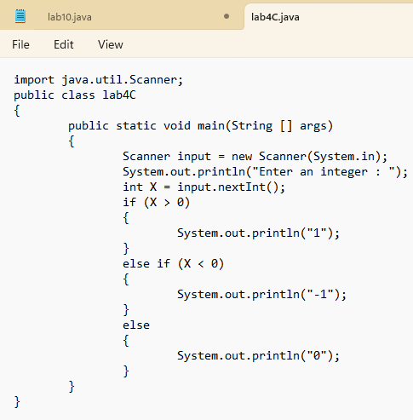

LAB 4
OUTPUT (TASK 4C):
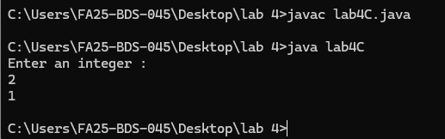

LAB 4
TASK 5: Equal numbers: Given three integers, determine how many of them are equal to each other. The program must print one of these numbers: 3 (if all are the same), 2 (if two of them are equal to each other and the third is different) or 0 (if all numbers are different).
INPUT (TASK 5):
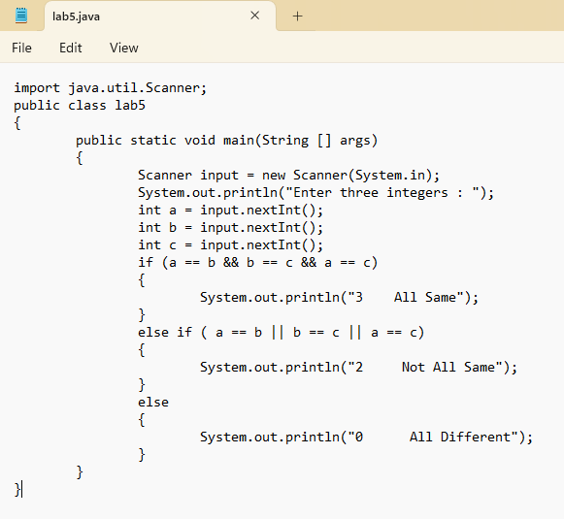

LAB 4
OUTPUT (TASK 5):
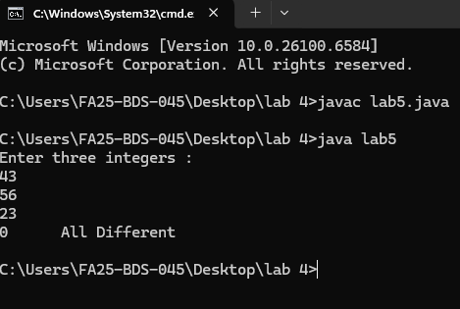

LAB 4
TASK 6: Write a program that prompts the user to enter a number within the range of 1 through 10. The program should display the Roman numeral version of that number. If the number is outside the range of 1 through 10, the program should display an error message. The following table shows the Roman numerals for the numbers 1 through 10
INPUT (TASK 6):
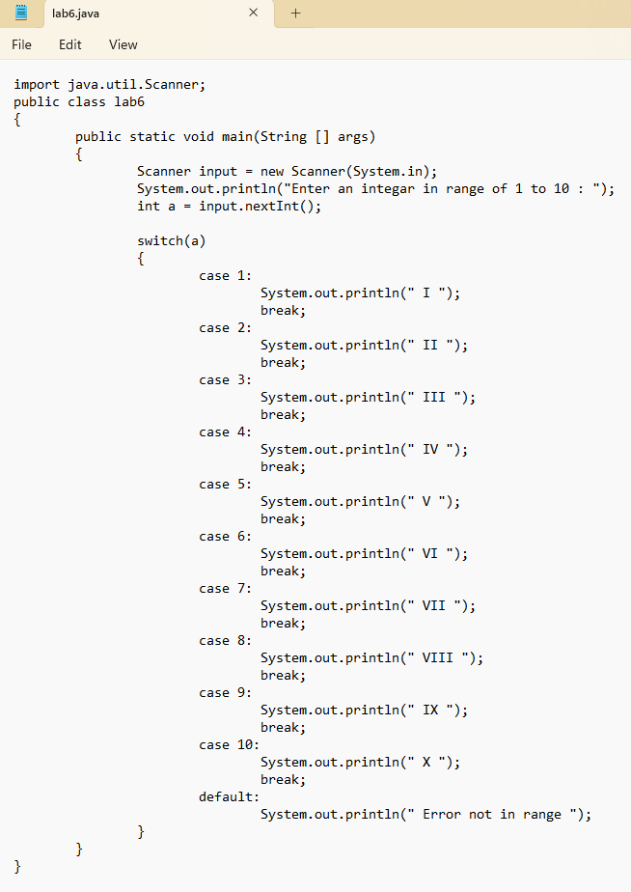
LAB 4
OUTPUT (TASK 6):
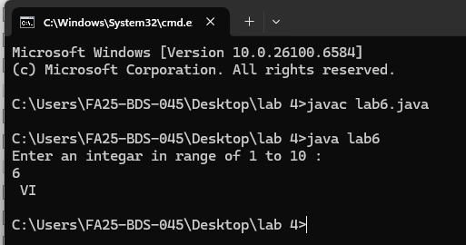

LAB 4
TASK 7: The area of a rectangle is the rectangle’s length times its width. Write a program that asks for the length and width of two rectangles. The program should tell the user which rectangle has the greater area, or if the areas are the same.
INPUT (TASK 7):
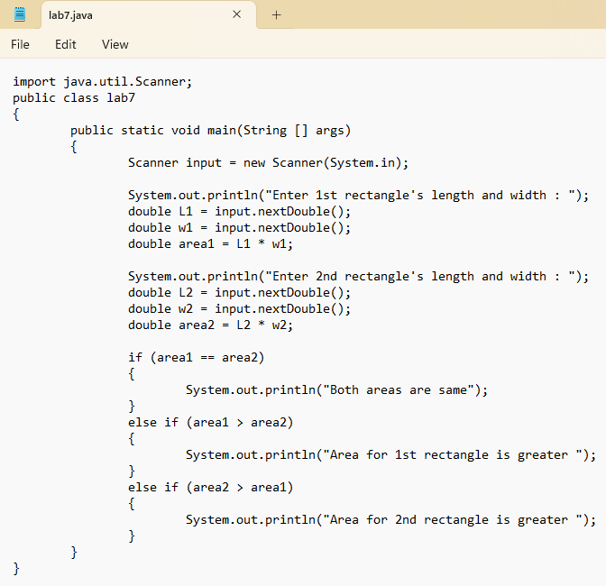

LAB 4
OUTPUT (TASK 7):
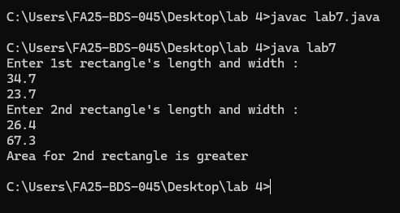

LAB 4
TASK 8: The date June 10, 1960, is special because when it is written in the following format, the month times the day equals the year: 6/10/60
Design a program that asks the user to enter a month (in numeric form), a day, and a two-digit year. The program should then determine whether the month times the day equals the year. If so, it should display a message saying the date is magic. Otherwise, it should display a message saying the date is not magic.
INPUT (TASK 8):
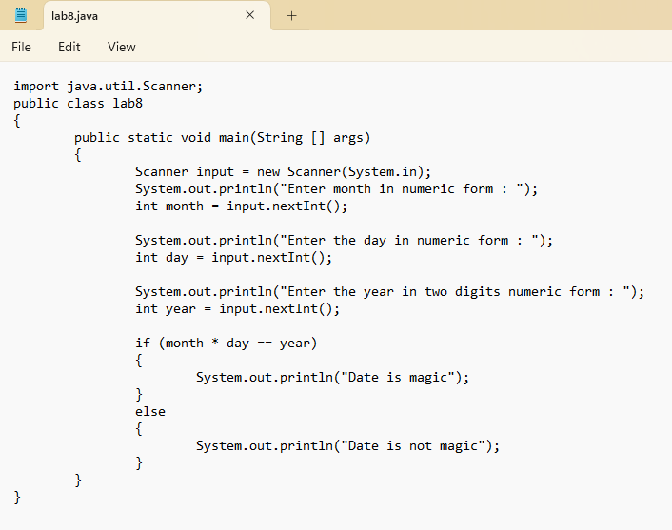

LAB 4
OUTPUT (TASK 8):
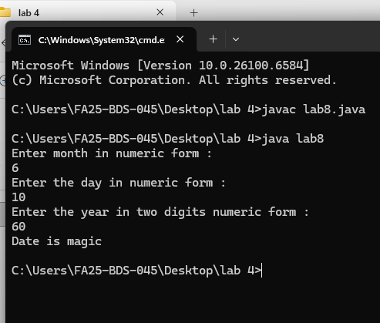

LAB 4
TASK 9: Create a change-counting game that gets the user to enter the number of coins required to make exactly one dollar. The program should prompt the user to enter the number of pennies, nickels, dimes, and quarters. If the total value of the coins entered is equal to one dollar, the program should congratulate the user for winning the game. Otherwise, the program should display a message indicating whether the amount entered was more than or less than one dollar.
INPUT (TASK 9):
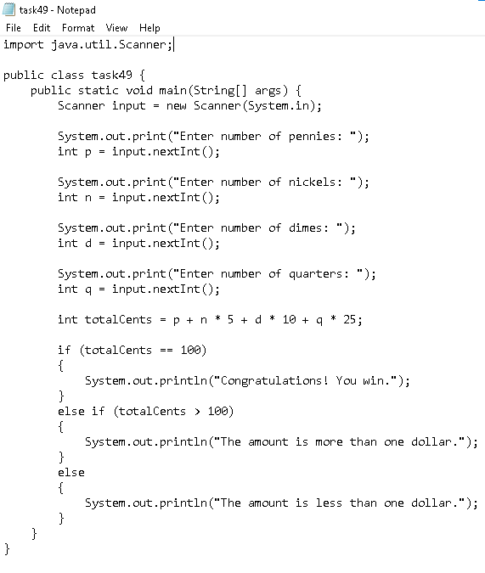
LAB 4
OUTPUT (TASK 9):
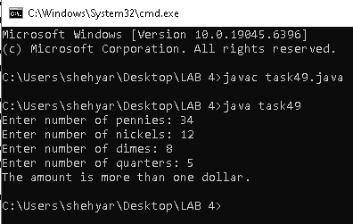

LAB 4
TASK 10: Serendipity Booksellers has a book club that awards points to its customers based on the number of books
purchased each month. The points are awarded as follows:
• If a customer purchases 0 books, he or she earns 0 points.
• If a customer purchases 1 book, he or she earns 5 points.
• If a customer purchases 2 books, he or she earns 15 points.
• If a customer purchases 3 books, he or she earns 30 points.
• If a customer purchases 4 or more books, he or she earns 60 points.
Write a program that asks the user to enter the number of books that he or she has purchased this month and displays the number of points awarded
INPUT (TASK 10):
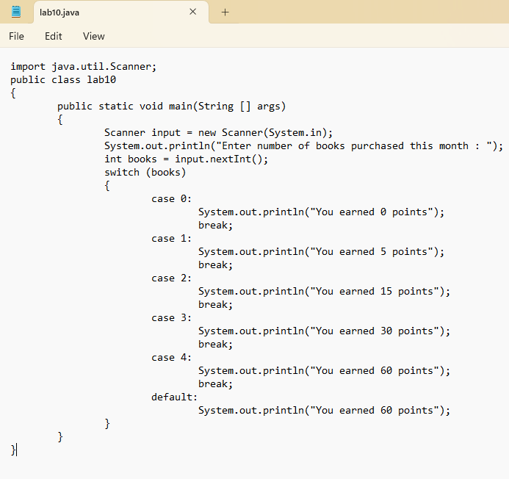
LAB 4
OUTPUT (TASK 10):
